**Edge Models of Multicubes**

(LA 6)

**Table of Contents**

**A Information for Teachers 2**

**B Learning Arrangement 10**

**C Materials / Language Support / Answer Key 11**

**1 The Idea**

|  |
| --- |
| This learning arrangement is based on a learning arrangement by Hengartner[1]  called „Mit Würfeln bauen“ (Building with Cubes). In Hengartner’s learning arrangements, the pupils investigate number sequences that result from the extension of cube structures, focusing on the number of unit cubes. The difference in this learning arrangement is, it is the not the number of unit cubes but rather the number of corners and edges of composite shapes that is under investigation.  Using edge models, the terms vertex, edge and face are reviewed. It is important in the introduction to point out that in the edge models, sticks are used to represent the edges and balls represent the vertices. Teachers should take this opportunity to point out the properties of models (agreement of essential features, simplification, idealization).  Pupils are given the opportunity to strengthen their spatial thinking abilities by imagining, planning and creating edge models of composite shapes using multiple unit cubes. In order to determine the number of edges (sticks) and corners (balls) needed, pupils need to be able to visualize which edges and vertices of individual cubes are shared in the composite structure.  Number sequences are investigated by calculating the materials needed to build „cube snakes“ (columns/rows of unit cubes). Due to the complex nature of possibilities that result from building with four or more unit cubes, the exploration of number sequences has been restricted to the investigation of „cube snakes“.  Pupils expand their mental math capabilities and reasoning by exploring the question of how to construct composite shapes using the least amount of materials.  This learning arrangement teaches and develops the ideas and competencies found in the mathematical themes of the Berlin State Curriculum [L3] *Raum und Form* (Space and Shape) and [L4] *Gleichungen und Funktionen* (Equations and Operations).  **Class 5/6** |

**2 Didatics and Teaching Methods** (practical tips for teachers)

|  |
| --- |
| **Duration:**  2 double lessons (90 minutes each)  **Introduction:**  Begin by reviewing or introducing the following terms: cube, vertex (vertices), edge, edge model and cube structure. Give the children time to practise the vocabulary using the card game (M2) or the interactive learning apps [matching game](https://learningapps.org/watch?v=pggb9q3pk21)[2] or [memory game[3]](https://learningapps.org/watch?v=pjzt59tmt21). Then compare and contrast cubes and edge models based on their specific properties. Emphasize the use of dots as a representation of the corners in edge models. Discuss that models need to have all the essential parts of the original, but may need to be simplified for educational purposes and therefore be a bit different than in real life.  Finally, challenge the pupils to construct composite structures using wooden blocks or snap cubes. Have them create different triple cube and quadruple cube composite shapes.  **Nr 1:**  Each pupil creates an edge model of a cube.  There are a number of materials that can be used for this activity. A professional magnetic building set could be purchased, but it is just as effective to use toothpicks, straws, or dried spaghetti noodles and peas, mini-marshmallows or clay. If you choose peas[4], please be aware that they need to be soaked for at least 12 hours in order to be soft enough to use.  Using fun materials is very motivating for pupils and leads them to ask further questions. If the children have not worked with such manipulatives before, please allow time for experimentation. Let individual pupils present their discoveries at the conclusion of this hands-on work phase.  **Nr 2:**  Challenge the pupils first to take a guess at how much material they will need and then allow them to test their guesses through actual construction.  **Nr 3:**  The focus of this task is for the pupils to analyse the pattern in the number of edges and corners needed for „cube snakes“. You can replace the term „cube snake“ with cube column or tower. The number of edges and vertices remains constant, even in „cube snakes“ that are not straight.  By limiting the amount of material available, pupils have to figure out a pattern for the number sequence. Pupils can be given the table (M1) for help. Quicker learners can be challenged to calculate the amount of materials needed for 20, 50 or 100 unit „cube snakes“ and possibly come up with a general formula.  **Nr 4:**  This task particularly targets mental math and spatial visualization by asking the questions: How is the number of edges and corners of a composite shape affected when I change the placement of a unit cube?  This is a challenging task and encourages pupils to make guesses and then test them, experiment, and finally defend their ideas. The pupils need to have enough materials to build an edge model and enough wooden or linking cubes with which to experiment. Quicker learners can be challenged to explain why the number of corners and edges changes depending on the composite shape even when the same number of unit cubes are used.  Pupils document their work by building the quadruple cube composite shape that they are studying with wooden or linking cubes and noting down the number of corners and edges needed. Gifted pupils could be given isometric dot paper (M4) on which to document their work.  Working with another pair of pupils allows for peer correction of possible mistakes and supports communication.  The products should be summarized in a short evaluation phase. The teacher should present all the possible different quadruple cube composite structures (M3) either enlarged on paper or projected onto the board and have the pupils note the number edges and corners.  The picture cards of the quadruple cube composite shapes (Form and Edge Model, M3) can be used for differentiation as a matching or memory game.  **Nr 5:**  The discovery made in Task 4, namely that compactly built composite structures need less building material, will now be transferred to composite shapes made out of eight unit cubes. If pupils can be given enough building material with which to experiment, then they can further investigate which eight cube composite structures need the most building materials.  **Nr 6:**  Pupils can use their findings from Task 3 to solve this task. They should attempt to solve it mathematically by calculating the answer.  If this task is too abstract for certain pupils, they could use manipulatives to build the composite structures or come up with their own experiment. |

**3 References to Berlin State Curriculum**

3.1 Process oriented mathematical standards of this learning arrangement[5]

* Mathematical reasoning: Pupils recognize relationships and structures and make assumptions about mathematical situations and check mathematical statements for correctness
* Solve problems mathematically: The pupils work on tasks for which they do not yet have a routine strategy. They recognize correlations and transfer solution strategies to similar situations.
* Using mathematical representation: Pupils select, use and develop suitable representations for dealing with mathematical facts and problems.
* Dealing with symbolic, formal and technical elements: Pupils use tables, terms, and equations to describe facts and circumstances
* Communicating mathematically: Pupils describe own procedures, comprehend solutions of others and jointly reflect solutions.

3.2. Content-related mathematical competencies of this learning arrangement[6]

|  |  |
| --- | --- |
| **Theme** | **Competency** |
| **Space and Shape** | The pupils can   * describe the properties of specific geometric objects * describe the relationship between specific geometric objects * build models of specific 3D shapes and draw the geometric figures * change the perspective and size of geometric shapes * describe the relationship between geometric objects and systemize them |
| **Equations and Operations** | The pupils can   * describe formulas for patterns and classification * represent classification and patterns * determine values for classification |

3.3 Themes and contents of this learning arrangement[7]

|  |  |
| --- | --- |
| **Theme** | **Content** |
| **Space and Shape** | The pupils   * recognize, name and describe geometric 3D shapes in the environment and on models using significant properties * describe perspective and size relationships of opposite or adjacent sides or surfaces of 3D geometric objects * build models of cubes (including edge models) |
| **Equations and Operations** | The pupils   * analyse and describe formulas for arithmetical and geometric patterns * represent geometric patterns (with numbers) * represent classification (with tables) * use formulas for arithmetical and geometric patterns to find further elements |

3.4 References to the general curriculum for language learning [8]

|  |  |
| --- | --- |
| **Standards of the general language learning curriculum** | The pupils can |
| **production/ speaking** | * describe circumstances and processes * report observations * articulate assumptions and justify them * present results from individual, partner and group work |
| **interaction** | * differentiate between spoken responses such as guesses and statements |

“3.5 References to the general curriculum for media education[9]

|  |  |
| --- | --- |
| **Standards of the general media education curriculum** | The pupils can |
| **Presentation** | * present results of individual and group work to an audience |

3.6 References to comprehensive/overarching themes[10]

|  |
| --- |
| * Mobility and Traffic Safety Education (Spatial Orientation) |

3.7 References to other subjects

|  |
| --- |
| * German (Language) * Science |

**4 Language Learning**

4.1 Possible difficulties in task directions

|  |  |  |
| --- | --- | --- |
| **Task** | **original text** | **spoken alternative** |
| 1 | How many balls and sticks did you use? | How many balls and sticks will you need? |
| 3 | Examine „cube snakes“. | Look at cube towers. |
| *Pupils must understand the following words:*  balls, sticks, composite shape/structure | | |

4.2 Vocabulary list for Comprehension

*The teacher must be sure that the pupils understand the following (mathematical) terms, before they work on the learning arrangement.*

|  |  |  |
| --- | --- | --- |
| **Nouns** | **Verbs** | **Other** |
| edge model  edge  vertex (vertices)  face  multicube  composite structure  double, triple, quadruple cube  „cube snake“  10-cube-snake | require  use  produce a table | particularly little material  each triple cube |

4.3 Subject relevant vocabulary and theme specific phrases

During the course of this learning arrangement, the pupils will actively use the following vocabulary and phrases. These will be the foundation for establishing a relevant word list to present their work products.

an edge model of a cube/ of a multicube

The 3D shape has ___ vertices and ___ edges ~~.~~

You need ___ balls and ___ sticks for the edge model.

___ balls and ___ sticks are required for the edge model.

In order to build a ....., I need __ balls and __ sticks.

The 4-cube snake is made up of __ balls and __ sticks.

To add another cube to the structure, I need __ balls and __ sticks.

With __ balls / sticks a cube snake / composite shape with ___ cubes can be built.

The number of balls / sticks increases /changes by ___.

The number of sticks / balls increases by ___ with the addition of each cube.

one needs / we need a lot of / particularly little material

**5 Material for the use of this learning arrangement**

|  |  |
| --- | --- |
| Amount | Material |
| per pupil | Learning arrangement (LU) |
| some | table template (M1) |
| per pair | memory game (M2) |
| optional | Cheat Sheet (tips and tricks) (M3) |
| optional | possible different quadruple cube composite structures (enlarged) (M3) |
| optional | as differentiation: laminated quadruple cube composite structures (M3) |
| optional | isometric dot paper (M4) |
|  | vocabulary cards (M5) |
| per pair | materials for building edge models:   * Magnetic building set * balls and rods **or** * peas and toothpicks (mini-marshmallows or clay and straws or dried spaghetti noodles are also possible)   approx. 20 balls und 40 sticks |
| 400 | wooden or snap cubes |

1. Build an edge model of a cube using balls and sticks. How many balls and sticks did you use?
2. Think: How many balls and sticks will you need for a double cube composite shape?

Balls: _____ Sticks: _____

Build and check.

1. Examine „Cube Snakes“.
2. How many balls and sticks do you need? Make a table.
3. Describe your discoveries.
4. Think: How much material would you need for a 10-cube snake?

For each triple cube figure you need 16 balls and 28 sticks.

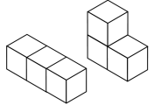

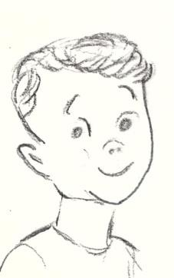

Is it the same for quadruple cube figures?

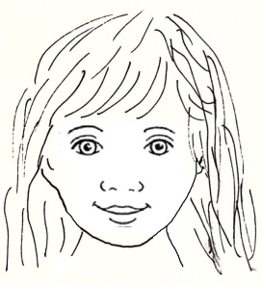

1. Examine different quadruple cube composite structures.
2. Document your discoveries and note down the number of balls and sticks.
3. Compare with another team.
4. Clara would like to build an eight cube composite structure which uses particularly little material.

Think: What will it look like? How much material will she need?

1. Clara und Jannik have 100 sticks. They want to use them all. Can they build an edge model of a composite shape? How many balls will they need?

**Differentiated template for the table in Task 2**

|  |  |  |  |  |  |  |  |  |  |
| --- | --- | --- | --- | --- | --- | --- | --- | --- | --- |
|  |  |  |  |  |  |  |  |  |  |
|  |  |  |  |  |  |  |  |  |  |
|  |  |  |  |  |  |  |  |  |  |

|  |  |  |  |  |  |  |  |  |  |  |
| --- | --- | --- | --- | --- | --- | --- | --- | --- | --- | --- |
| **Cube** |  |  |  |  |  |  |  |  |  |  |
| Balls |  |  |  |  |  |  |  |  |  |  |
| Sticks |  |  |  |  |  |  |  |  |  |  |

|  |  |  |  |  |  |  |  |  |  |  |
| --- | --- | --- | --- | --- | --- | --- | --- | --- | --- | --- |
| **Cube** | **1** | **2** | **3** |  |  |  |  |  |  |  |
| Balls |  |  |  |  |  |  |  |  |  |  |
| Sticks |  |  |  |  |  |  |  |  |  |  |

|  |  |  |  |  |  |  |  |  |  |  |
| --- | --- | --- | --- | --- | --- | --- | --- | --- | --- | --- |
| **Cube** | **1** | **2** | **3** |  |  |  |  |  |  |  |
| Balls | 8 |  |  |  |  |  |  |  |  |  |
| Sticks | 12 |  |  |  |  |  |  |  |  |  |

**Memory Cards**

|  |  |  |  |
| --- | --- | --- | --- |
|  |  |  |  |
| cube | face | edge | vertex |
|  |  |  |  |
| double cube | triple cube | quadruple cube | edge model |

*The following interactive games can be used to practise vocabulary:*

|  |  |
| --- | --- |
| [**Matching Game**](https://learningapps.org/watch?v=pggb9q3pk21)  <https://learningapps.org/watch?v=pggb9q3pk21> | **[Memory Game](https://learningapps.org/watch?v=pjzt59tmt21)**  <https://learningapps.org/watch?v=pjzt59tmt21> |

 

**Cheat Sheet for Task 3** *(optional)*

Ein Bild, das Licht, Silhouette enthält.
****

**Tips and Tricks:**

* Think: How did the number of balls change?

Can you see a pattern?

* How did the number of sticks change?

Can you see a pattern?

**Picture cards of possible quadruple cube composite structures**

|  |  |
| --- | --- |
|  |  |
|  |  |
|  |  |

|  |  |
| --- | --- |
|  |  |
|  |  |
|  |  |
|  |  |
|  |  |

**Isometric dot paper**

**Vocabulary Cards**

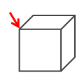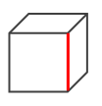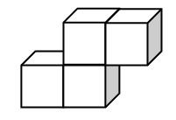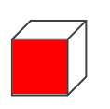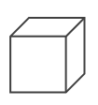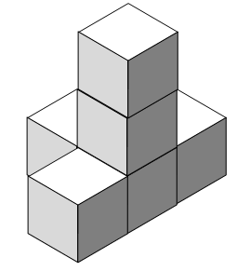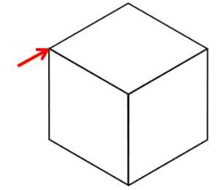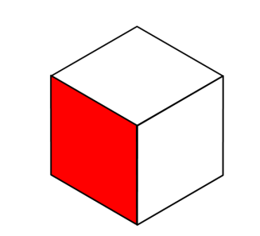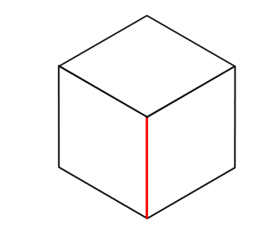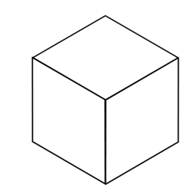

vertex

edge

face

cube

multicube

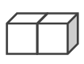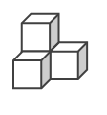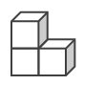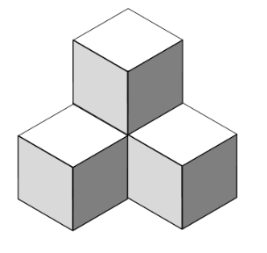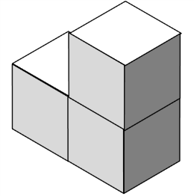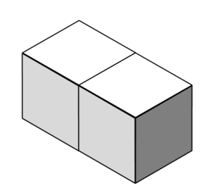

quadruple cube

triple cube

double cube

3D drawing

edge model

**Nr 1**

quadra-cube composite shape

You need 8 balls and 12 sticks for a cube.

**Nr 2**

For a double cube structure you need 12 balls and 20 sticks.

**Nr 3**

|  |  |  |  |  |  |  |  |  |  |  |  |  |
| --- | --- | --- | --- | --- | --- | --- | --- | --- | --- | --- | --- | --- |
| **Cubes** | **1** | **2** | **3** | **4** | **5** | **6** | **7** | **8** | **9** | **10** | **20** | **n** |
| Balls | 8 | 12 | 16 | 20 | 24 | 28 | 32 | 36 | 40 | 44 | 84 | 4n+4 |
| Sticks | 12 | 20 | 28 | 36 | 44 | 52 | 60 | 68 | 76 | 84 | 164 | 8n+4 |

**Nr 4**

Cube Snake: 20 balls and 36 sticks

Winners’ Podium: 20 balls and 36 sticks

“Cube square”: 18 balls and 33 sticks

Cube corner: 20 balls and 36 sticks

All other quadruple cube composite shapes: 20 balls und 36 sticks

**Nr 5**

Compact multi-cube composite structures need particularly little material, for example a 2 x 2 x 2-cube. For this you only need 27 balls and 54 sticks.

*Extra task for quicker learners:*

A lot of material is needed for an octo-cube snake: 36 balls and 68 sticks.

**Nr 6**

Carrying on with the pattern from the table in Task 3, one can compute that from 100 sticks, a 12-cube long snake can be built. You would need 52 balls.

|  |  |  |
| --- | --- | --- |
| Picture | Page | Source |
| Illustrations |  | created by iMINT Grundschule Mathematik |
| drawings of children | 10 | created by iMINT Grundschule Mathematik |
| symbols for individual, partner and group work | 10 | created by iMINT Grundschule Mathematik |
| Cheat sheet symbol (lightbulb) | 16, 17 | free to use  <https://pixabay.com/de/idee-licht-gl%C3%BChbirne-lampe-birne-153974/> [05.01.2018] |

1. Hengartner, Elmar, Hirt, Ueli, Wälti, Beat (2006): Lernumgebungen für Rechenschwache bis Hochbegabte.

   Natürliche Differenzierung im Mathematikunterricht. Klett und Balmer-Verlag, Zug 2006, S. 117-121
2. <https://learningapps.org/watch?v=pggb9q3pk21> Use the QR-Code to access.
3. <https://learningapps.org/watch?v=pjzt59tmt21> Use the QR-Code for this program.
4. Green, unpeeled peas work best. After being soaked, they can be kept refrigerated for up to three days.
5. vgl. Rahmenlehrplan Jahrgangsstufen 1-10, Teil C Mathematik, S. 19-21, Berlin, Potsdam 2015
6. vgl. Rahmenlehrplan Jahrgangsstufen 1-10, Teil C Mathematik, S. 22-31, Berlin, Potsdam 2015
7. . vgl. Rahmenlehrplan Jahrgangsstufen 1-10, Teil C Mathematik, S. 31ff, Berlin, Potsdam 2015
8. vgl. Rahmenlehrplan Jahrgangsstufen 1-10, Teil B Fachübergreifende Kompetenzentwicklung, S. 6-10, Berlin, Potsdam 2015
9. vgl. Rahmenlehrplan Jahrgangsstufen 1-10, Teil Fachübergreifende Kompetenzentwicklung, S. 15-22, Berlin, Potsdam 2015
10. vgl. Rahmenlehrplan Jahrgangsstufen 1-10, Teil B Fachübergreifende Kompetenzentwicklung, S. 24ff, Berlin, Potsdam 2015